**Aim: Write a program to implement Breadth first search Traversal on Tree using Python (without using any libraries or packages of python).**

* **Use class concept of python (Tree Class, Node Class).**
* **Use class to implement Data structure to be used in program.**
* **Tree & Output should look like below:**

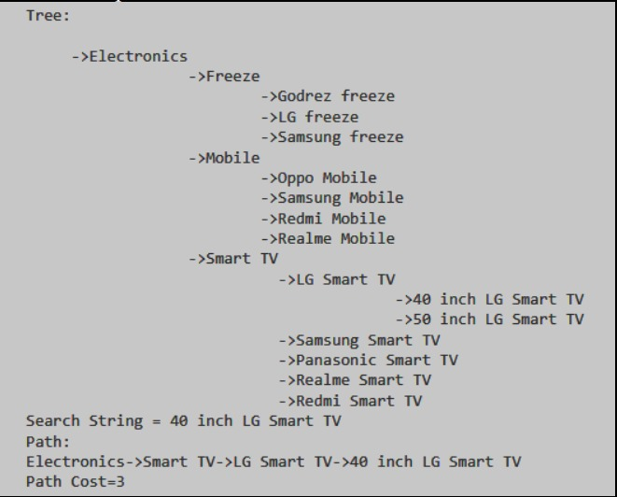

**Program:**

# Contains the node attributes

# @parent(Object of node class),

# @nodeValue(String),

# @childNodeList(List of child Node Object)

# @nodeLevel(Integer)

class node:

    def __init__(self, parent, value, child):

        self.parent = parent

        self.value = value

        self.child = child

        self.level = 0

        if parent != None:

            self.level = self.parent.level + 1

    def addChildNode(self, childNode):

        self.child.append(childNode)

    def spaceCount(self):

        strParent = ""

        if self.parent == None:

            strParent = str(self.parent)

        else:

            strParent = "None"

            tempNode = self.parent

            while tempNode != None:

                strParent += "->" + tempNode.value

                tempNode = tempNode.parent

        return len(strParent) + 1

    def __repr__(self):

        strReturn=""

        if(self.parent==None):

            strReturn = "Tree: "

        strReturn += "\n"

        strReturn += " " * self.spaceCount()

        # map() function returns a map object(which is an iterator) of the results

        # after applying the given function to each item of a given iterable (list, tuple etc.).

        # Syntax:- map(fun, iter)

        # @fun : It is a function to which map passes each element of given iterable.

        # @iter : It is a iterable which is to be mapped.

        #join(): The join() method takes all items in an iterable and joins them into one string.

        #@return : String

        strReturn += "->" + str(self.value) + "  ".join(map(str, self.child))

        return strReturn

# Contains root node data also use to add node in tree

# @rootNode (Node class object)

class tree:

    def __init__(self, rootnode):

        self.root = rootnode

    def addNode(self, value, parentNode):

        nd = node(parentNode, value, [])

        parentNode.addChildNode(nd)

        return nd

    def __repr__(self):

        # call built in __repr__ method of node class

        return str(self.root)

# Create tree with root node

t1 = tree(node(None, "Animal", []))

# Add node in tree

# @nodeValue (String)

# @parentNode (Object of node class)

node1 = t1.addNode("Reptile",t1.root)

node1_1 = t1.addNode("Lizard",node1)

node1_1_1 = t1.addNode("Salamander",node1_1)

node1_2 = t1.addNode("Snake",node1)

node1_3 = t1.addNode("Bird",node1)

node1_3_1 = t1.addNode("Canary",node1_3)

node1_3_1_1 = t1.addNode("Tweetle",node1_3_1)

node2 = t1.addNode("Mammal",t1.root)

node2_1 = t1.addNode("Equine",node2)

node2_1_1 = t1.addNode("Horse",node2_1)

node2_1_2 = t1.addNode("Zebra",node2_1)

node2_2 = t1.addNode("Bovine",node2)

node2_2_1 = t1.addNode("Cow",node2_2)

node2_2_1_1 = t1.addNode("Bessle",node2_2_1)

node2_3 = t1.addNode("Canine",node2)

node2_3_1 = t1.addNode("Lassle",node2_3)

# Print the tree t1

print(t1)

# Function use for search node using Breadth First Search Algo

def bfs(searchString, rootNode):

    node = [rootNode]

    while node:

        tempNode = node.pop(0)

        if tempNode.value == searchString:

            return tempNode

        else:

            # extend(): The extend() method will extend

            # the iterable by appending all the elements from the iterable to the end of the list.

            # Example:

            # lis=[1,2]

            # lis.extend([3,4,5])

            # output: lis[1,2,3,4,5]

            node.extend(tempNode.child)

    return None

# Function use to find cost of searching node

def findCost(self):

    stringDisp = []

    ndd = self.parent

    while ndd != None:

        # append(): The append() method will add an item to the end of the list.

        # Example :

        # lis=[1,2]

        # lis.append([3,4,5])

        # output: lis[1,2,[3,4,5]]

        stringDisp.append(ndd.value)

        ndd = ndd.parent

    stringDisp.reverse()

    return stringDisp

searchSTR = input("\nEnter String: ")

print("\nSearch String: ",searchSTR)

# Perform Breadth First Search. Searching Start from rootNode

breadthF = bfs(searchSTR, t1.root)

if breadthF == None:

    print("Sorry, we can't find this string.")

else:

    # Find Cost of searching node from searchNode to rootNode

    res = findCost(breadthF)

    strPath = res[0]

    for i in range(1,len(res)):

        strPath += " -> " + res[i]

    strPath += " -> " + breadthF.value

    print("Path: " + strPath)

    print("Path Cost: " + str(len(res)))

**Output:**

